18 – 1 What is the nervous system?

Key Terms
neuron: nerve cell
dendrite: fiber that carries messages to the nerve cell body
axon: fiber that carries message away from a nerve cell body
synapse: gap between the axon of one cell and the dendrite of another

The Nervous System The nervous system controls all of your body’s activities. The nervous system is made up of the brain, the spinal cord, and nerves. Nerves carry information to the spinal cord and brain. Other nerves then carry messages from the brain and spinal cord to the muscles and glands. The muscles and glands carry out the orders of the brain and spinal cord.

The Central Nervous System Your brain is the control center of your body. The brain is made up of mass of nervous tissue. The brain is protected by your skull. The spinal cord is made up of many nerves that extend down your back. The spinal cord is protected by the backbone. The brain and spinal cord make up the central nervous system.

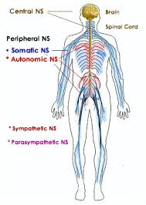
Nerve Cells Thirty-one pairs of nerves branch out from your spinal cord. These nerves branch many times and extend to all parts of your body. Each of the nerves in your body is made up of nerve cells called neurons. Neurons can be either large or small. Some neurons are among the largest cells in your body. In fact, one neuron in your leg can be as long as 1meter.
The job of a neuron is to carry messages. Messages travel through a neuron in only one direction.
The dendrites carry messages toward the nerve cell body, or center of the neuron. The axon carries messages away from the cell body. The cell body contains the nucleus of the neuron. It contains the most cytoplasm.

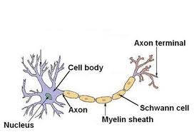

Synapses The axon of one nerve cell normally does not touch the dendrites of the next nerve cell. Usually, there is a small gap between the two cells. This gap is called a synapse. Chemicals released by the axon carry messages across the synapse to the dendrites of the next neuron.

CHECKING CONCEPTS

- What is the job of the nervous system?

- What are the parts of the nervous system?

- What parts make up the central nervous system?

- What is the neuron?

