The Outsiders
STUDY
QUESTIONS
Record your answers on a separate sheet
of paper. You must answer in complete sentences.

Chapter One
- Thomas Howell as Ponyboy Curtis

What makes Ponyboy different from the rest of his Greaser crew? Why are these good traits for a narrator of this story to have?

  - How do Ponyboy’s relationships with Darry and Sodapop differ? Explain.

  - What has Johnny learned from the gang that he couldn’t learn from his parents? What’s the irony in this? What can you learn from your friends that you can’t learn from your own family?

  - As they are falling asleep, how does Ponyboy react to what Sodapop tells him about Darry?

  - Do you think Darry loves Ponyboy? Why does he treat Ponyboy the way he does?

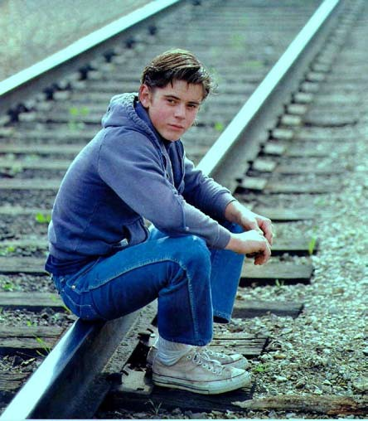
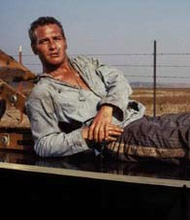
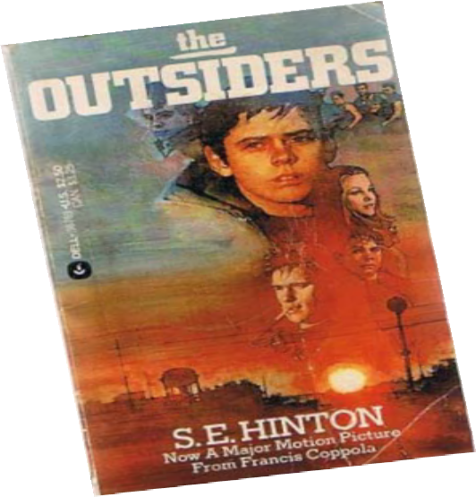

Paul Newman in Cool Hand Luke

At the end of the chapter, Ponyboy says, “I lie to myself all the time. But I never believe me.” Explain what he means. In what way is this idea true for you, as well?

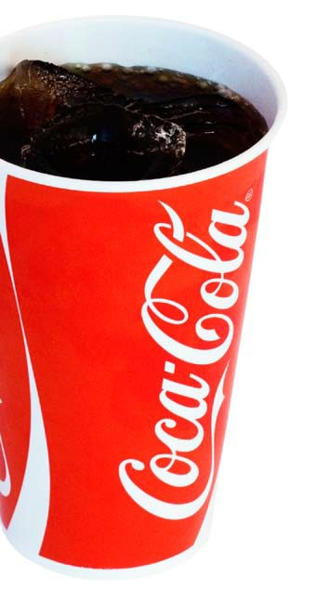
The Outsiders
Chapter Two
    - Ponyboy and Sodapop are the boys’ actual names. What does this show you about their parents?

    - Why doesn’t Ponyboy like referring to Sodapop as a dropout? In what way does this label fit? In what way does it not fit?

    - Four months ago, Johnny was attacked by a group of Socs, leaving a scar on his face “that he would carry all of this life.” Johnny was actually scarred in more than one way by the attack. Explain.

    - During the attack, Johnny’s “T-shirt was splattered with blood.” What color was his T-shirt originally? Symbolically, why do you suppose Hinton made the T-shirt that color instead of, say, green or black?

    - When recalling the night of Johnny’s attack, Ponyboy says that he noticed Dally was especially disturbed by the viciousness of the beating and looked ill. He says, “Dally has seen
people killed on the streets of New York’s West Side. Why did he look sick now?” There’s two possible reasons why Dally would look so
sick in that moment. Explain them both.

    - In ch. 1, Ponyboy tells us that Steve and Sodapop like to fight and drag-race cars to release some of their pent-up energy. In this chapter, Two-Bit says that a fair fight without
blades “blows off steam better than anything.” Even today, some young men enjoy these things. Explain how this type of reckless behavior might actually be innocent, as Ponyboy suggests.

    - To Ponyboy, what’s the difference between a gang and a pack?

    - Ponyboy is confused about the different treatment his friends give toward girls they know and girls they don’t know. Explain what he means. Give an example of how this holds true in our world today.

    - When Dally brings each of the girls a soda, what does Cherry do? What does Marcia do? Which girl do you think Ponyboy respects more? If you were one of the girls, which move would you make?

    - At the end of the chapter, Ponyboy says that the Socs have it so easy in life – “good grades, good cars, good girls, madras and Mustangs and Corvairs – Man, I thought, if I had worries like that I’d consider myself lucky. I know better now.” First, examine how Ponyboy’s opinion in the first part of this quote is hypocritical, given his earlier stance about Sodapop being labeled a “dropout.” Second, look at the last four words, which
foreshadow an eventual change in Ponyboy’s thinking. Give at least two guesses of the kinds of problems these wealthier kids might have. It’s okay if you’re wrong, but I want you to take a guess.

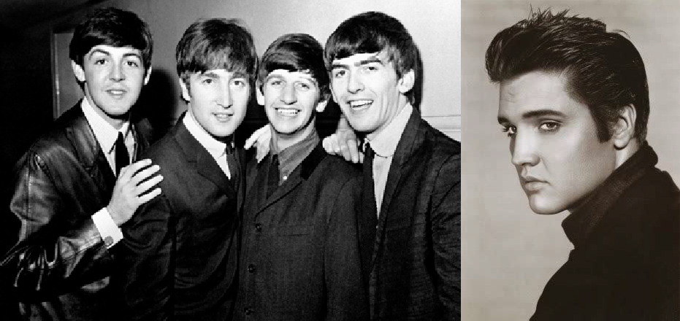
The Outsiders
The Beatles
Can you name all four of these guys?

Elvis Presley

Chapter Three
- Explain the differences between the two social groups in regards to The Beatles and Elvis Presley. Why would each group have the preference that it holds?

- Cherry explains that part of what keeps the two groups apart is that the Greasers are overly emotional and the Socs are too emotionally cool/numb. Of the two extremes, which one do you think is better? Explain your answer.

- Ponyboy says that he and Johnny “understood each other without saying anything.” Explain how this is possible. Have you ever had this kind of relationship with a friend or sibling? Explain.

- Sodapop’s connection to the horse named Mickey Mouse can actually be seen as a metaphor for his relationship with Darry. How so?

- Why would Cherry be attracted to Dally? Do your best to explain the complicated, conflicting emotions that Cherry is feeling.

- How long ago did the Curtis parents die? Explain how this amplifies all of the emotions the boys are sorting through.

- What happens when Ponyboy comes home at 2 a.m., long after his curfew?

- Why does Johnny like it better when his father is hitting him than when he ignores him?

Diane Lane
as Cherry Valance

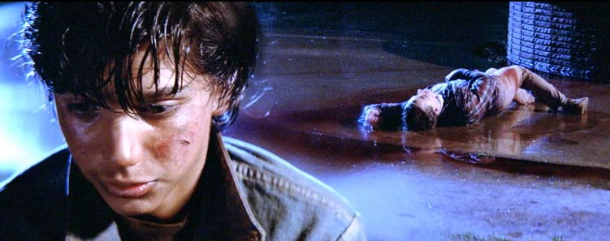
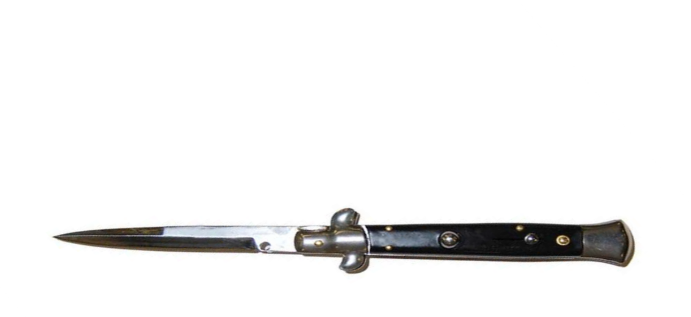
The Outsiders

Chapter Four
- Reeling pickled. Boozed up. Crocked. The Greasers use a lot of different words/phrases for “drunk.” Why, do you suppose, they have so many euphemisms for gettting drunk? What does this show us about their world?

- If you were on a jury and saw a video-recording of what happened when Johnny stabbed Bob, what would your sentence for Johnny be?

- In this chapter, Ponyboy says that “the fight for self-preservation had hardened [Dally] beyond caring.” Is this true for Johnny, too? For Ponyboy?

- What’s the irony of Ponyboy’s dream of living in the country finally coming true in this chapter?

- If Johnny and Ponyboy had come to your house in the middle of the night seeking help, what would your advice have been to them?

- What color are Ponyboy’s eyes? Symbolically, what’s interesting about this?

- What does “premonition” mean? If you need to, look it up in a dictionary and write down the definition. How is this word’s usage in the last paragraph of the chapter an example of foreshadowing?

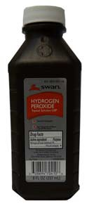
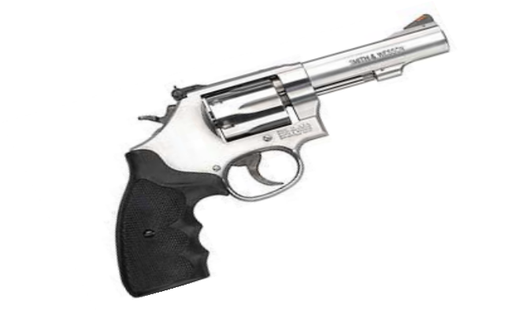
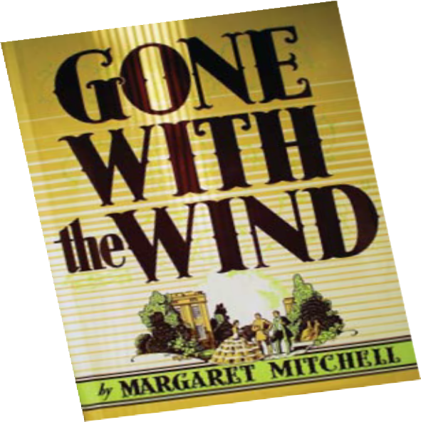
The Outsiders

Chapter Five
  - When Ponyboy awakens, he notices that Johnny’s jean jacket “had somehow got thrown across me.” What does this show us about Johnny?

  - Ponyboy doesn’t want to cut and bleach his hair with peroxide, but Johnny knows they need to alter their appearances. According to Ponyboy, how does a military or prison haircut serve as a method to break young men from their social class?

  - After shouting and crying in the church, Ponyboy wakes up feeling stronger and more in control of his emotions. Explain how this episode is similar to Steve and Sodapop’s need to fight or drag-race cars.

in the incident that leads Johnny to compare Dally to Southern gentlemen in Gone With the Wind, the novel

4. Expla the old Ponybo were h

5. Of does

6. P Fro ex ch

7
par
y’s reading. Do you agree with Johnny that Dally’s actions eroic?

all the boys, Ponyboy likes Dally the least. Why? What this realization show us about Ponyboy?

onyboy has trouble understanding the meaning of Robert st’s poem, “Nothing Gold Can Stay.” In your own words, plain the poet’s theme. Then, connect that theme to aracters and events from this story.

. Johnny compares the Curtis brothers to their deceased ents. Which boy looks/acts like which parent? Which
one of your parents are you most like? What similarities (physical or behaviorial) do you share?

    - What is a heater? Why does Dally have one with him?

    - Who is the unexpected spy for the Greasers? Why would this person be willing to serve in this role?

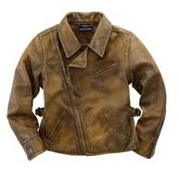
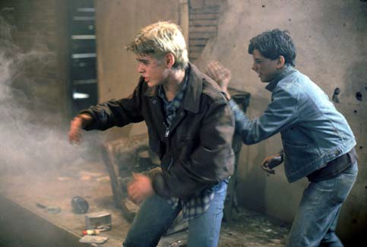
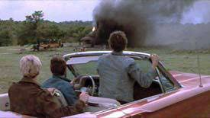
The Outsiders

Chapter Six
- Dally says that he’s completely indifferent to his parents who abandoned him and that they hold
no influence over him. Ponyboy believes him. Do you? Explain your answer.

- Why doesn’t Dally want Johnny to turn himself in?

- Even in the face of extreme danger inside the burning church, Johnny smiles and shows a rare level of confidence, even joy. Why, do you suppose, he reacts this way?

- When Ponyboy and Johnny need a place to hide out, they go to an abandoned church. In this chapter, witnesses say the boys were “sent from heaven” to help the
little children from the burning building, which Ponyboy described as “a red hell.” Symbolically, what’s going on here with all of this religious imagery?

- Dally does two separate things that help save Ponyboy’s life. Explain them both.

- What makes Ponyboy realize that Darry really does love him?

What word do you see here? Now, flip your paper over.

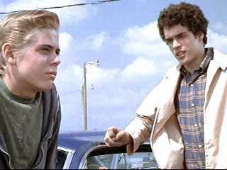
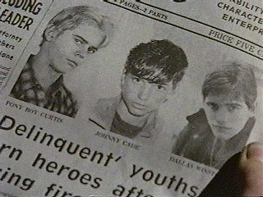
The Outsiders

Chapter Seven

Johnny is in the hospital. What is his condition?

- Why would being paralyzed and/ or wheelchair-bound be worse for Johnny than for someone else?

- Ponyboy says that people often seem younger when they’re asleep. Why, do you suppose, this is true?

- Two-Bit takes issue with the newspaper that says Johnny, Ponyboy, and Dally “turn heroes” and says, “Y’all were heroes from the beginning. You just didn’t ‘turn’ all of a sudden.” Thinking about Two-Bit’s background and family, why does he think so highly of the boys?

- According to Randy, what was Bob’s biggest problem?

- Randy suggests that all kids want their parents to set limits and to tell them “no” because this gives kids “something solid to stand on.” Is he right or wrong? How do you react when your parents don’t allow you to do something?

- Randy has a problem that can be described as a catch-22. Explain what a catch-22 is (you will likely need to look this up in a dictionary) and then explain how this is what Randy faces in regards to tonight’s rumble.

- After talking with Randy, Ponyboy says he is comforted knowing that “things were rough all over.” Explain what he means by this.

The Outsiders

Ponyboy and Two-Bit after visiting Johnny

Chapter Eight

At the beginning of the chapter, what does the doctor say that alarms Ponyboy about the gravity
of Johnny’s condition? Why does Ponyboy notice this when Two-Bit does not?

- Ponyboy says, “We needed Johnny as much as he needed the gang. And for the same reason.” Explain what Ponyboy means.

The Curtis brothers in happier days

Compare and contrast
Ponyboy’s mother to Johnny’s mother.

- For the first time in the book, Ponyboy defends Darry’s type of tough love. What does he tell Two- Bit that explains why Darry is harder on him than his own parents were?

Ralph Macchio as Johnny Cade

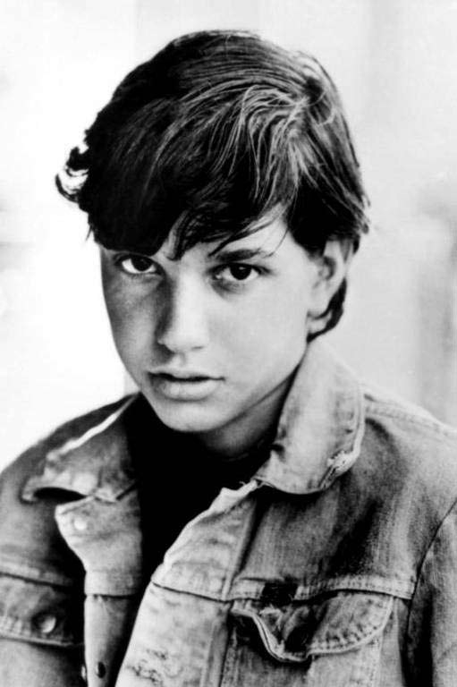
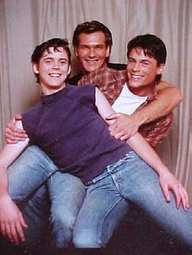
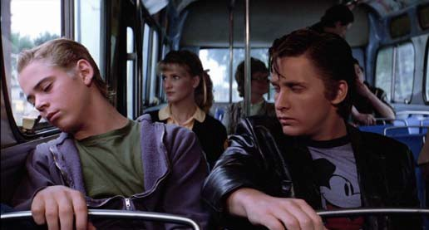

Two-Bit and Ponyboy agree that, if it weren’t for the two younger Curtis brothers, Darry would probably be a Soc. Explain how this is true.

- Explain Cherry’s conflicted feelings about Johnny and Bob.

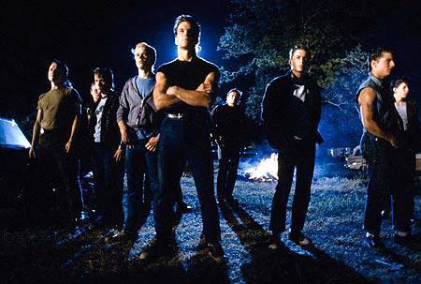
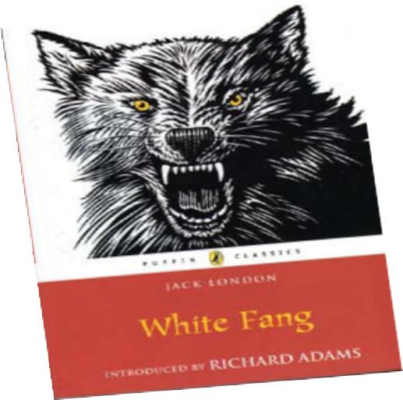
The Outsiders

Chapter Nine
  - As the boys are preparing to leave for the rumble, Ponyboy no longer feels proud of the things that used to matter to him, like being identified as a “hood” and having long, greasy hair. He also notices that Darry doesn’t
fit the traditional Greaser mold. List some of the things mentioned in this chapter that show Darry
is more than the “Greaser” label shows.

  - Ponyboy doesn’t want to fight at all, but he realizes that: Soda fights for .
Steve fights for . Darry fights for . Two-Bit fights for .
  - What’s the difference between Tim Shepard’s gang and Darry’s gang? Explain how this difference might give the Curtis brothers and their friends an advantage in life.

  - What’s ironic about Paul Holden being the first Soc to step up to Darry’s challenge?

  - Describe the comparison that Ponyboy makes between Darry/Paul at the beginning of the rumble and a scene from a Jack London novel. How is this an appropriate description of the scene?

  - What were Johnny’s last words to Ponyboy? What did Johnny mean?

The Outsiders
At the end of ch. 9, Dally convinces a cop to escort them to the hospital.

Chapter Ten

At the beginning of the chapter, a helpful stranger drives Ponyboy home. Symbolically, what’s a message we can take away from this exchange with the driver?

Moments after their arrival, Johnny dies and Dally is undone.

Ponyboy, who was Johnny’s best friend, is able to handle Johnny’s death better than Dally, who becomes emotionally unglued. Why is this, do you suppose?

- Describe three of Dally’s actions that confirm we wanted to die that night.

- How long has Ponyboy been in-and-out of consciousness?

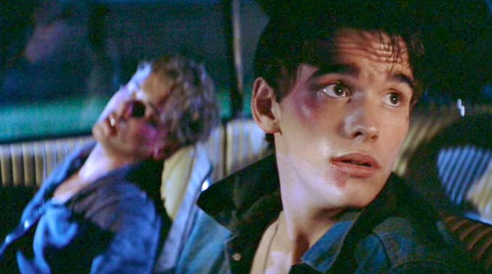
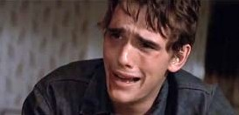
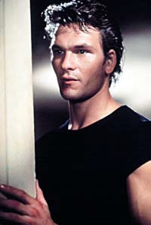
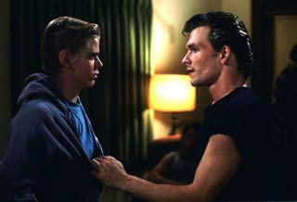
- How do Ponyboy’s actions while he was delirious show that he has fully mended his fractured relationship with Darry?

Darry, played by Patrick Swayze, keeps a watchful eye over Ponyboy.

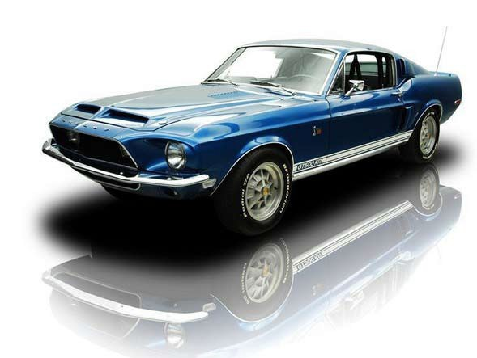
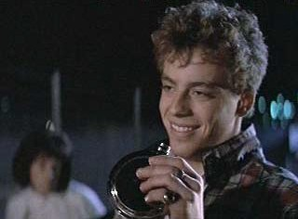
The Outsiders

Bob Sheldon on the night he was killed.

Chapter Eleven

True or false? Bob’s parents are partly responsible for their son’s death. Explain your answer.

  - Ponyboy compares Bob to several of the members of the Greaser gang, noting Bob’s smile
was like Sodapop’s, his eyes might have been like Johnny’s, and his recklessness and hot-temper were certainly like Dally’s. What is Hinton’s point in drawing such clear connections between Bob and the Greasers?

  - Why, do you suppose, would Ponyboy rather have someone’s hate than his/her pity?

  - Ponyboy has been a thoughtful voice of reason as the narrator of the story, but at the end of this chapter he’s changed and is now what is called an “unreliable narrator.” What’s going on with Ponyboy here in the last few pages of the chapter? Put on your psychologist’s hat as you answer this question.

  - What’s another piece of evidence at the very end of the chapter that Darry and Ponyboy have repaired their relationship?

The Outsiders

Chapter Twelve

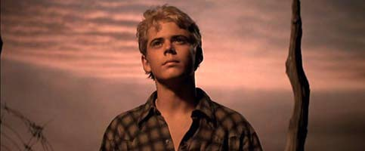
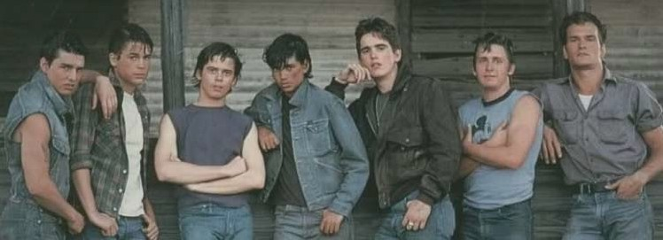
- What do you suppose the doctor told the judge?

- Define the word, “acquitted.” Why is this the correct sentence for the judge to issue?

- When Ponyboy’s English teacher takes “into consideration the circumstances” of the past few weeks and gives Ponyboy a special assignment to help him raise his grade, what does Ponyboy think the teacher means? What does the teacher actually mean?

- Why doesn’t Ponyboy feel scared when he’s approached by the Socs in the parking lot? In what way does this passage echo the sentiment expressed by Dally before his death?

- In the parking lot scene, what piece of evidence shows that Ponyboy’s still a good kid at his core and will never be as tough as Dally?
- Darry says that “you don’t just stop living because you lose someone.” Explain how this is true.

- Reading between the lines, explain what happened between Sandy and Sodapop.

- After Sodapop gets Darry and Ponyboy to realize what their squabbling does to him
emotionally, how does the weather reflect the mood of the characters and the scene?

- According to Ponyboy, what was especially rare and wonderful about Johnny?

- What does Ponyboy write for his English assignment? How do you feel about the ending of this book?

