“But first, let me draw this selfie.”
EQ: How can we convey our own personal interest within a self-portrait?
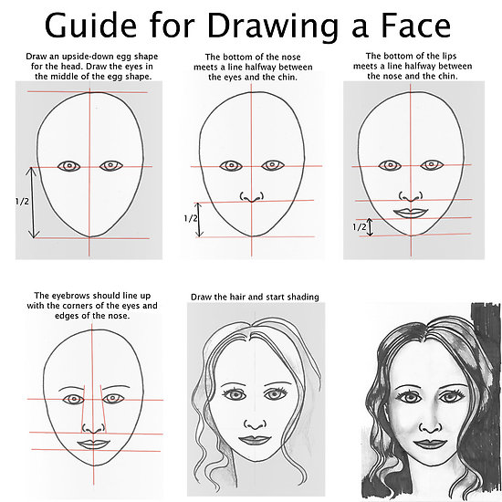
Materials: 12X18 white paper, pencil, and varies other materials. (mixed media)

Procedure:
- Roughly sketch out all of your face or half.
- Write text or draw pictures to complete the portrait.
- Use a variety of materials to jazz up your project.
GPS: VA8PR.3a. Develops a variety of skills in drawing (e.g., observational, illusion of form, tonal rendering, perspective. scale drawing) to convey meaning and idea. VA8PR.3b. Produces original two-dimensional artworks using a variety of media.

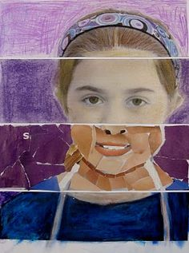
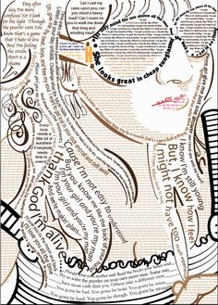
Student Samples:
