“It’s all about that Space.”
EQ: How can we create positive and negative space within an artwork?
Procedure:
Materials:
12X18 white paper, 12X18 black paper, scissors, glue, and x-acto knife, magazines
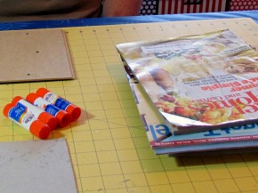
- Put your name on a white 12X18 sheet of construction paper and turn it over. Begin cutting out strips of colors and textures that you find in magazines. Do NOT just cut out cool or pretty pictures. Look for different colors with stuff that can be textures, like clouds or wood or carpet. Glue down your strips as you cut them out, overlapping the edges so that all of the white paper is covered.
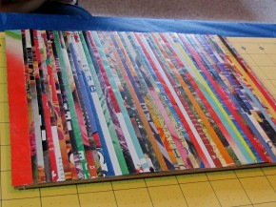
- The next step is designing your top black sheet. You must draw a design with pencil on your black 12 X 18 paper. This design is different from most drawings. The shapes and lines in your design can’t overlap. If your design is intricate enough, you will be allowed to use an x-acto knife to complete the next step.
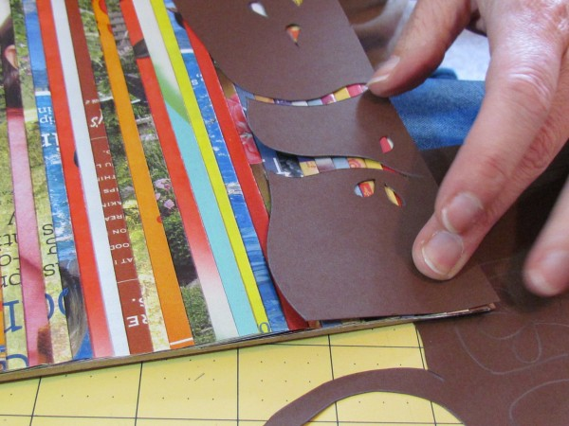
- Cut out the shapes in your black paper that will reveal your design. If you are using an x-acto knife, make sure the cutting mat stays under your paper at all times. AS SOON as you finish cutting out your design, turn the knife back in to your teacher and put away the cutting mat.
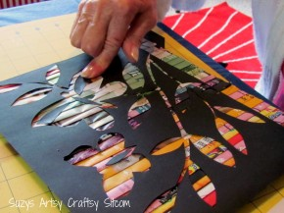
- Finally, glue down your top black paper with a single line of glue at either the top and bottom or both sides of your paper. Your project is finished! The negative spaces you created when you cut out your design have now been revealed as the “positive” colorful art. Take a picture of your artwork!
GPS:
VA8MC.1a. Uses elements of art and principles of design to expand imagination and develop meaningful ideas.
VA8MC.1b. Visualizes unique ideas and formulates artistic concepts to expand the imagination using a variety of approaches.

