“It’s all about that Shape.” Remix

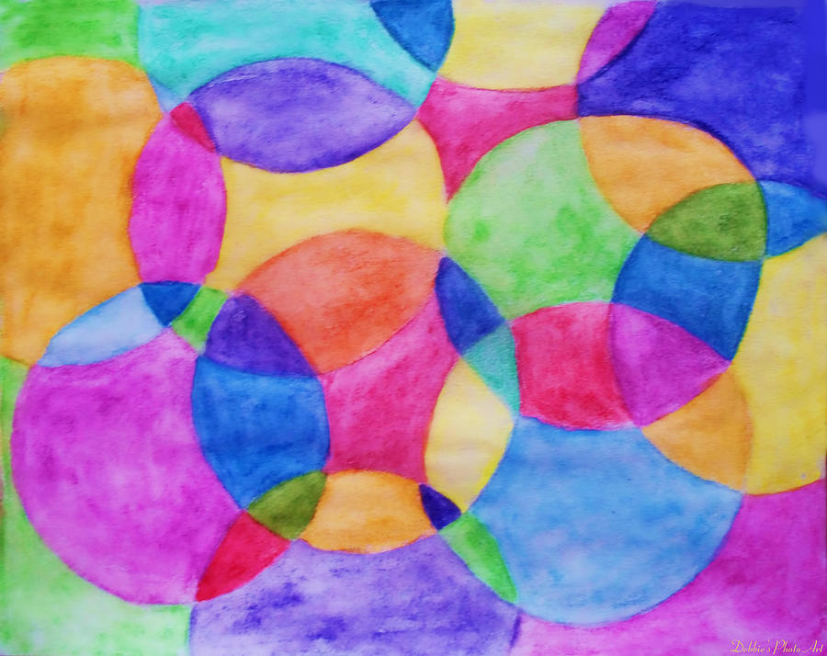
EQ: How can we create shape in a large area of space?

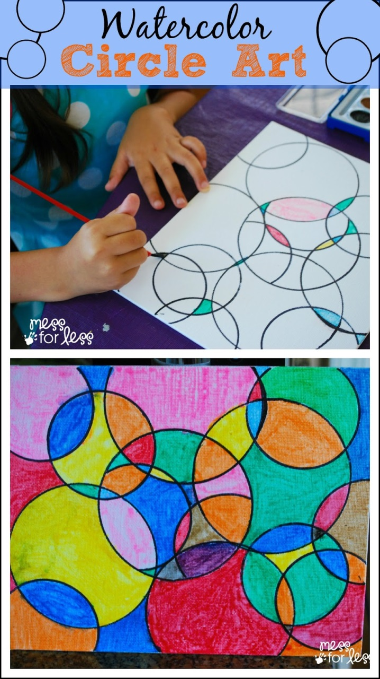
Materials: 12X18 sheet of watercolor paper, black tempera paint, watercolor paint, brush, cup of water, empty paper towel roll

Procedure:

- On a sheet of 12X18 sheet of watercolor paper take the end of the paper roll and dip it into the black tempera paint.
- Then place the circle designs made by the paper rolls in random locations on the paper overlapping circles.
- Place on drying rack and let dry.
- After the black tempera paper is dry, using watercolor carefully paint the new shapes that were created by the black circles.
- Take a picture when you’re done.

GPS: VA8PR.2b. Produces increasingly complex original works of art reflecting personal choices and increased technical skill.
VA8PR.3b. Produces original two-dimensional artworks using a variety of media.

